Let's Recap

ESG is not a journey we take on our own, but one that we take together.
By addressing our biases and understanding others' perspectives, we can start having better conversations about ESG, raising awareness and broadening our understanding. This, in turn, will help us move forward on our ESG journey.
Engaging Others on ESG
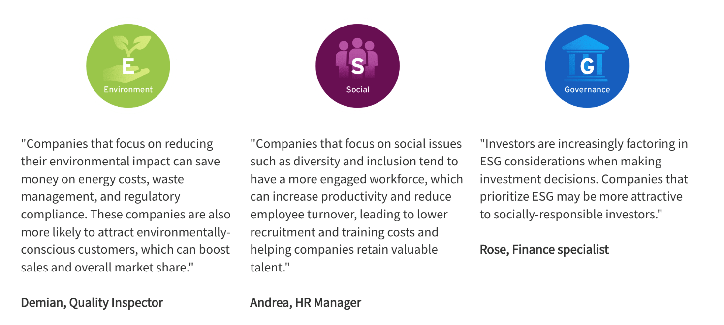Environment: "Companies that focus on reducing their environmental impact can save money on energy costs, waste management, and regulatory compliance. These companies are also more likely to attract environmentally-conscious customers, which can boost sales and overall market share." - Bemian, Quality Inspector. Social: "Companies that focus on social issues such as diversity and inclusion tend to have a more engaged workforce, which can increase productivity and reduce employee turnover, leading to lower recruitment and training costs and helping companies retain valuable talent." - Andrea, HR Manager. Governance: "Investors are increasingly factoring in ESG considerations when making investment decisions. Companies that prioritize ESG may be more attractive to socially-responsible investors." - Rose, Finance specialist
Key Takeaways
- More and more people are starting to care more about environmental and social issues, so they want companies to be responsible and sustainable. However, some people are still not sure about ESG principles.
- Some think that it might cost too much money, or that it is hard to measure its impact. Some also worry that some companies might pretend to care about ESG principles without actually doing anything.
- Despite these concerns, ESG principles are becoming more and more important for companies to succeed in the long run, and there is hope that more people will support them.
Additional Resources
- BoardEx Global Gender Balance Report
- The Kuna: the endangered last tribe of the Caribbean
- Talking Trash, a project exposing plastic-related greenwashing
- Diversity Wins: How inclusion matters
- Accessing Climate Finance Challenges
- Six month update on progress in advancing the Just Energy Transition Partnership (JETP)
- In emerging markets, patience is a virtue in the race to net zero
- How to Identify Cognitive Bias: 12 Examples of Cognitive Bias

